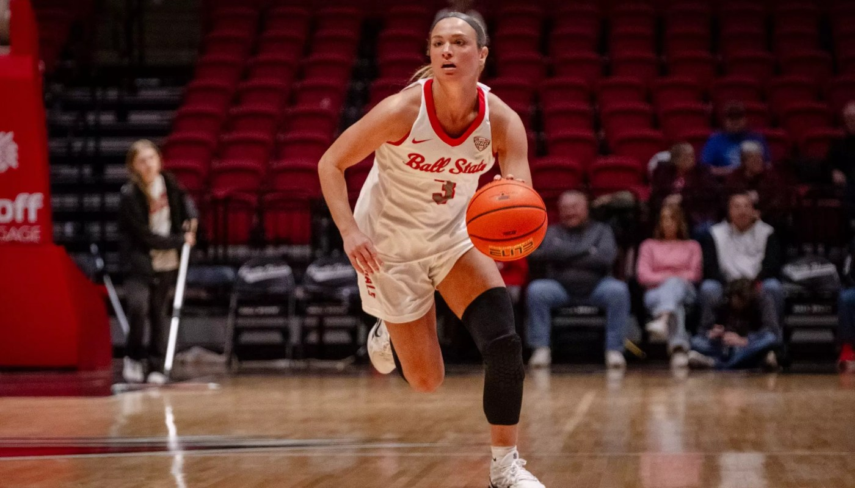
Ball State / Basketball / College / MAC / Written Content

Massive second quarter gives Ball State a commanding win over Huskies

by Dylan Kindig
February 4, 2026

MUNCIE, Ind.- The Ball State Cardinals hosted the Huskies from Northern Illinois in their second and final meeting of the regular season. The Cardinals dominated this game with a 83-48 win over the Huskies.
Ball State came into this game after a high-scoring affair with Kent State in which Tessa Towers led the way with 29 points and 11 rebounds. The Cardinals went into this game winning two of their last three games.
The Huskies came into this matchup losing their last three to Eastern Michigan, Miami (OH), and Central Michigan. NIU held a 2-8 MAC record before their meeting with the Cardinals.
The first quarter ended with a four-point difference with Ball State leading 17-13. In the second quarter, the Ball State scoring ramped up to take an 11-point lead with 4:50 left in the half.
At halftime, Ball State led the Huskies 43-21 in a huge first half performance led by Grace Kingery. Kingery scored 20 points by the midway break making six of her seven attempts from beyond the arch. The Cards dominated the second quarter by winning 26-8 over the Huskies.
Ball State started the second half as hot as they ended the first. The Cardinals came out of the break scoring 10 unanswered points to force the Huskies to call a timeout within the first three minutes of the half.
The Cardinals won the third quarter in dominate fashion in a 31- 10 score. The depth of the Cardinal’s bench came out to play this quarter. Coach Sallee put in every player he has on his bench in the second half.
Although she only scored three points in the second half, Grace Kingery led the Cards in points in the end. She finished with 23 points followed by Tessa Towers with 12 points and five rebounds.
Ball State scored very efficiently against the Huskies by shooting 58.5% from the field and 53% from beyond the arch in their matchup with NIU. The Cards also assisted on 22 of their 31 field goal makes.
Coach Sallee talked about his teams scoring and playmaking ability.
“I think we just overwhelmed them without ball movement,” said Sallee. “When we’re moving the ball like that and she (Grace Kingery) can get those kind of looks, it ends up being good.”
The Cardinal defense also played very impressive. They held NIU to shoot 31% as a team from the field and 20% from three.
The Cards took down the Huskies 83-48 in a blowout win at home. Ball State sealed their tenth win in Mid American play and their 18th overall win of the season. The Cardinals face Troy next at home on Feb. 7 in the MAC-Sun Belt Challenge.
Coach Sallee said this about their matchup with Troy.
” I love that it’s at home,” said Sallee. “This is like an NCAA Tournament game or a game in Cleveland. It’s going to be fun competing out of the league. Troy is tremendous.”

https://keeonsports.com/massive-second-quarter-gives-ball-state-a-commanding-win-over-huskies/

